DATE:12/11/24

1. CHECK IF TWO STRINGS ARE ANAGRAMS OF EACH OTHER

Given two strings s1 and s2 consisting of lowercase characters. The task is to check whether two given strings are an anagram of each other or not. An anagram of a string is another string that contains the same characters, only the order of characters can be different. For example, act and tac are an anagram of each other. Strings s1 and s2 can only contain lowercase alphabets.

Note: You can assume both the strings s1 & s2 are non-empty

Input: s1 = "geeks", s2 = "kseeg" Output: trueExplanation: Both the string have same characters with same frequency. So, they are anagrams.

CODE:

package util;

import java.util.*;

public class Anagram {

public static void main(String[] args) {

Scanner sc = new Scanner(System.in);

System.out.println("Enter the first string:");

String s1 = sc.nextLine();

System.out.println("Enter the second string:");

String s2 = sc.nextLine();

System.out.println((areAnagrams(s1, s2)));

}

public static boolean areAnagrams(String s1, String s2) {

if (s1.length() != s2.length()) {

return false;

}

char[] str1 = s1.toCharArray();

char[] str2 = s2.toCharArray();

Arrays.sort(str1);

Arrays.sort(str2);

return Arrays.equals(str1, str2);

}

}

OUTPUT:

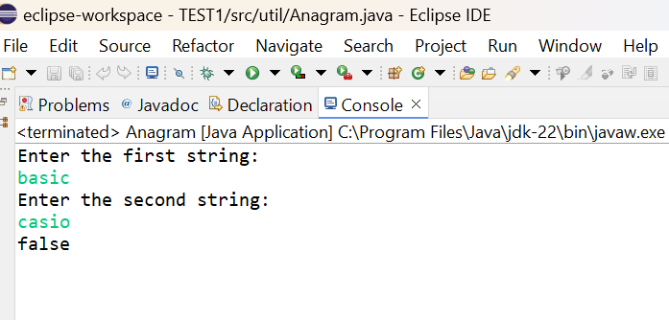

TIME COMPLEXITY: O(n log n)

2.ROW WITH MAXIMUM NUMBER OF 1’S

.You are given a 2D array consisting of only 1's and 0's, where each row is sorted in non-decreasing order. You need to find and return the index of the first row that has the most number of 1s. If no such row exists, return -1.

Note: 0-based indexing is followed.

Input: arr[][] = [[0, 1, 1, 1],

[0, 0, 1, 1],

[1, 1, 1, 1],

[0, 0, 0, 0]]

Output: 2

Explanation: Row 2 contains 4 1's.

CODE:

**package** src;

**public** **class** Maximumone {

**static** **int** *R* = 4 ;

**static** **int** *C* = 4 ;

**static** **int** rowWithMax1s(**int** mat[][], **int** R, **int** C)

{

**boolean** flag = **true**;

**int** max_row_index = 0, max_ones = 0;;

**for**(**int** i = 0 ; i < R ; i++){

**int** count1 = 0 ;

**for**(**int** j = 0 ; j < C ; j++){

**if**(mat[i][j] == 1){

count1++;

flag = **false**;

}

}

**if**(count1>max_ones){

max_ones = count1;

max_row_index = i;

}

}

**if**(flag){

**return** -1;

}

**return** max_row_index;

}

**public** **static** **void** main(String[] args) {

**int** mat[][] = { {0, 0, 0, 1},

{0, 1, 1, 1},

{1, 1, 1, 1},

{0, 0, 0, 0}};

System.***out***.print("Index of row with maximum 1s is " + *rowWithMax1s*(mat,*R*,*C*));

}

}

OUTPUT:

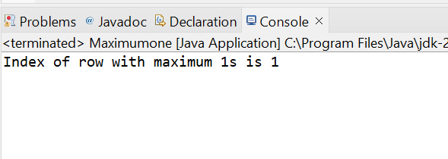

TIME COMPLEXITY:O(R*C)

3.LONGEST CONSEQUITIVE SUBSEQUENCE

. Given an array arr of non-negative integers. Find the length of the longest sub-sequence such that elements in the subsequence are consecutive integers, the consecutive numbers can be in any order.

Input: arr[] = [2, 6, 1, 9, 4, 5, 3]

Output: 6

Explanation: The consecutive numbers here are 1, 2, 3, 4, 5, 6. These 6 numbers form the longest consecutive subsquence

CODE:

package src;

import java.util.Arrays;

public class Longestsequence {

public static int findLongestConseqSubseq(int[] arr) {

if (arr.length == 0) return 0;

Arrays.sort(arr);

int longestStreak = 1;

int currentStreak = 1;

for (int i = 1; i < arr.length; i++) {

if (arr[i] == arr[i - 1]) continue;

if (arr[i] == arr[i - 1] + 1) {

currentStreak++;

} else {

longestStreak = Math.max(longestStreak, currentStreak);

currentStreak = 1;

}

}

longestStreak = Math.max(longestStreak, currentStreak);

return longestStreak;

}

public static void main(String[] args)

{

int arr[] = { 1, 9, 3, 10, 4, 20, 2 };

int n = arr.length;

System.out.println(

"Length of the Longest "

+ "contiguous subsequence is "

+ findLongestConseqSubseq(arr));

}

}

OUTPUT:

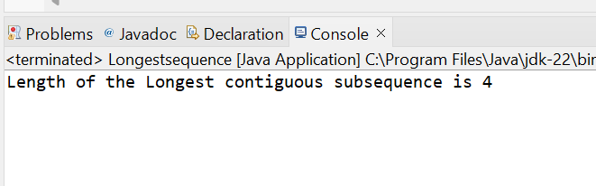

TIME COMPLEXITY: O(N)

4.LONGEST PALINDROME IN A STRING

Given a string S, find the longest palindromic substring in S. Substring of string S: S[ i . . . . j ] where 0 ≤ i ≤ j < len(S). Palindrome string: A string which reads the same backwards. More formally, S is palindrome if reverse(S) = S. Incase of conflict, return the substring which occurs first ( with the least starting index ).

CODE:

**package** util;

**import** java.util.Scanner;

**public** **class** Palindrome {

**public** **static** **void** main(String[] args) {

Scanner sc = **new** Scanner(System.***in***);

System.***out***.println("Enter the string:");

String s = sc.nextLine();

Palindrome obj = **new** Palindrome();

String longestPalindromicSubstring = obj.longestPalindrome(s);

System.***out***.println("Longest Palindromic string: " + longestPalindromicSubstring);

}

**public** String longestPalindrome(String s) {

**int** start = 0;

**int** end =0;

**for**(**int** i=0;i<s.length();i++){

**int** len1 = palindrome(s,i,i);

**int** len2 = palindrome(s,i,i+1);

**int** len = Math.*max*(len1,len2);

**if**(len>end-start){

start = i-(len-1)/2;

end = i+len/2;

}

}

**return** s.substring(start,end+1);

}

**private** **int** palindrome(String s,**int** left,**int** right){

**while**(left>=0 && right<s.length() && s.charAt(left)==s.charAt(right)){

left--;

right++;

}

**return** right-left-1;

}

}

OUTPUT:

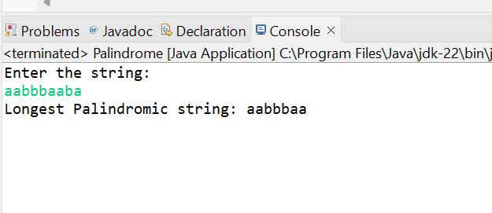

TIME COMPLEXITY:O(N^2)

5.RAT IN A MAZE PROBLEM

Consider a rat placed at (0, 0) in a square matrix mat of order n* n. It has to reach the destination at (n - 1, n - 1). Find all possible paths that the rat can take to reach from source to destination. The directions in which the rat can move are 'U'(up), 'D'(down), 'L' (left), 'R' (right). Value 0 at a cell in the matrix represents that it is blocked and rat cannot move to it while value 1 at a cell in the matrix represents that rat can be travel through it. Note: In a path, no cell can be visited more than one time. If the source cell is 0, the rat cannot move to any other cell. In case of no path, return an empty list. The driver will output "-1" automatically.

Input: mat[][] = [[1, 0], [1, 0]] Output: -1

Explanation: No path exists and destination cell is blocked.

CODE:

**package** src;

**import** java.util.ArrayList;

**import** java.util.List;

**public** **class** RatInMaze {

**public** **static** List<String> findPath(**int**[][] mat, **int** n) {

List<String> paths = **new** ArrayList<>();

**if** (mat[0][0] == 0 || mat[n - 1][n - 1] == 0) {

**return** paths;

}

**boolean**[][] visited = **new** **boolean**[n][n];

*dfs*(mat, n, 0, 0, "", paths, visited);

**if** (paths.isEmpty()) {

paths.add("-1");

}

**return** paths;

}

**private** **static** **void** dfs(**int**[][] mat, **int** n, **int** row, **int** col, String path, List<String> paths, **boolean**[][] visited) {

**if** (row == n - 1 && col == n - 1) {

paths.add(path);

**return**;

}

visited[row][col] = **true**;

**if** (*isSafe*(mat, n, row + 1, col, visited)) {

*dfs*(mat, n, row + 1, col, path + "D", paths, visited);

}

**if** (*isSafe*(mat, n, row, col - 1, visited)) {

*dfs*(mat, n, row, col - 1, path + "L", paths, visited);

}

**if** (*isSafe*(mat, n, row, col + 1, visited)) {

*dfs*(mat, n, row, col + 1, path + "R", paths, visited);

}

**if** (*isSafe*(mat, n, row - 1, col, visited)) {

*dfs*(mat, n, row - 1, col, path + "U", paths, visited);

}

visited[row][col] = **false**;

}

**private** **static** **boolean** isSafe(**int**[][] mat, **int** n, **int** row, **int** col, **boolean**[][] visited) {

**return** row >= 0 && row < n && col >= 0 && col < n && mat[row][col] == 1 && !visited[row][col];

}

**public** **static** **void** main(String[] args) {

**int**[][] mat = {

{1, 1},

{1, 1}

};

**int** n = mat.length;

List<String> result = *findPath*(mat, n);

**for** (String path : result) {

System.***out***.println(path);

}

}

}

OUTPUT:

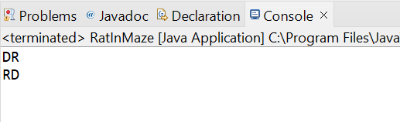

TIME COMPLEXITY: O(2*(N x N))